Biostat 656: Lab 7
Purpose: Review an example of a multilevel model fit using WinBUGS and presented in a substantive (meaning non-statistical) journal.
Criteria for Choosing Article: A random slope and random intercept model fit using WinBUGS.
Article: Tekkis et al. The Association of Coloprotology of Great Britain and Ireland study of large bowel obstruction caused by colorectal cancer. Annals of Surgery 2004; 240(1):76-81.
Problem
Post-operative mortality for malignant bowel obstruction (MBO) is high. Is it possible to develop models to predict who is likely to die? Given this information, physicians and patients can make better-informed decisions about whether surgery would be beneficial for a given patient.
Goal of article:
a) "Investigate results of surgery for malignant large bowel obstruction and to present broad, overall benchmarks by which future standards may be set."
b) "Identify risk factors that determine postoperative survival of patients with MBO and to develop a risk stratification system..."
Data
Primary outcome was in-hospital postoperative mortality. Secondary outcome was length of hospital stay.
9 patient and procedural risk factors were examined.
Statistical Analysis
1) Unadjusted odds ratios and demographics examined. (Table 1)
2) "A three-level hierarchical logistic regression model was used for identifying independent risk factors of operative mortality and their interaction terms, as well as adjusting for the clustering of adverse outcomes within individual hospitals."
-"Initial model estimates were derived using a second order penalized quasi likelihood estimation"
- WinBUGS used to fit model
-Gamma(.001,.001) used as prior; the authors do not specify for which parameters such a prior was used. The authors might have used normal priors for the fixed effect coefficients.
-Three levels: Patient, surgeon, hospital
-Random intercept across surgeon and hospital
-Random slope on age covariate for hospital.
Notice how they were able to explain development of the starting values ("Load Inits" values) and Bayesian priors.
3) Note model presented on page 79; it is possible to present equations in substantive journals! Notice that the editors had a hard time with the word logit: "log it" and "logit"
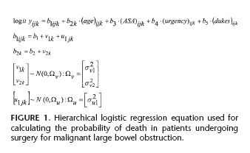
Results
Notice on page 79 how the authors fit a line of logit(P(Died)) vs. age across urgency level for each hospital. This provides a visual display of the results so that the reader can see how the relationship of age, mortality, and urgency level varies across hospitals. This is a nice way of presenting results from a random effects model; the interpretation of the random effects model is accessible to the reader.
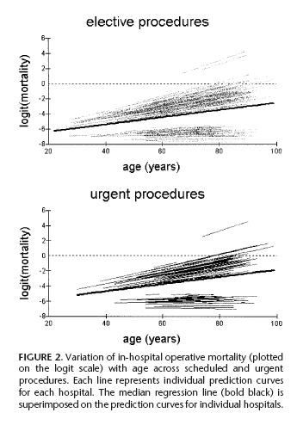

Discussion
"The penalty for ignoring the clustered nature of patients within hospitals is that the standard error of the regression coefficients, which describes the performance of each hospital is lower.(citation provided)" Is this statement correct?

"Hierarchical models work on the basic principle that the true performance rates for different centers are drawn from a normal distribution and, as a consequence the performance rate is weighted according to the number of cases submitted...The unit coefficients are therefore shrunk toward the population mean with greater shrinkage for smaller centers."
-This statement seems logical, but it is not related to the results. Rhetorical question: Where in the results is evidence of shrinkage presented?
"It is no longer safe to define standards such as postoperative mortality in terms of a single number without adjustment."
"Difficult clinical decisions may be easier if the MBO model is applied in the preoperative setting to provide patients with an estimated numerical probability of survival as part of the counseling and decision-making process of informed consent."
The results present evidence of how risk factors are associated with mortality after surgery for MBO.
This paper provides a template for how to present novel statistical methods to an audience that might not be very statistically sophisticated. Translational research in statistics is research that attempts to present a statistical method to scientists in an easy to understand manner. Some of the most cited statistics papers were not published in statistics journals. Baron and Kenny’s article on investigating mediation has been cited in over 4500 articles; it was published in the Journal of Personality and Social Psychology in 1986. Hence, translational research by scientists can be very influential.

