Biostatistics 140.653

Maximum January Temperature Example: Handout 1 of 3

Part 1: Exploration and basic model fitting

! Purpose: To describe maximum January temperatures (1931-1960) according to
site latitude and longitude. Sixty-two U.S. cities were examined. See last pages
of handout for data (courtesy Mosteller & Tukey, pp. 73-4).

! Exploration: Scatterplots of temperatures versus each of the predictors, and
of the predictors versus each other, are displayed on the next page as a
scatterplot matrix.

- R commands:

. rawdata <- read.table("TEMP.ASC.txt")
. fdeg <- rawdata$V1
. lat <- rawdata$V2
. longi <- rawdata$V3

. pairs(~fdeg+lat+longi)

 What do you notice?

!Model fitting: We will describe how temperatures vary with latitude and
longitude. We’ll begin by fitting simple linear regressions (SLR) of temperature on latitude and temperature on longitude:

> R commands:

. rawdata[1:10,]

. V1 V2 V3
1 61 30 88
2 59 32 86
3 30 58 134
4 64 33 112
5 51 34 92
6 65 34 118
7 55 37 122
8 42 39 104
9 37 41 72
10 41 39 75

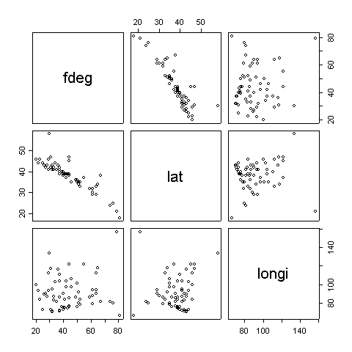

. tempdata <- subset(rawdata, (rawdata$V3<130 & rawdata$V2<=50 & rawdata$V2>20))
. fdeg <- tempdata$V1
. lat <- tempdata$V2
. longi <- tempdata$V3

. latc <- lat-39
. longc <- longi-76

. cbind(fdeg, lat, longi, latc, longc)[1:10,]

fdeg lat longi latc longc
[1,] 61 30 88 -8.440678 -2.101695
[2,] 59 32 86 -6.440678 -4.101695
[3,] 64 33 112 -5.440678 21.898305
[4,] 51 34 92 -4.440678 1.898305
[5,] 65 34 118 -4.440678 27.898305
[6,] 55 37 122 -1.440678 31.898305
[7,] 42 39 104 0.559322 13.898305
[8,] 37 41 72 2.559322 -18.101695
[9,] 41 39 75 0.559322 -15.101695
[10,] 44 38 77 -0.440678 -13.101695

! First, the simple linear regression (SLR) of temperature on latitude. This gives us
the so-called “total” effect of latitude on temperature:

. summary(lm(fdeg~latc))

lm(formula = fdeg ~ latc)

Residuals:
Min 1Q Median 3Q Max
-8.767 -3.782 -0.900 1.363 22.811

Coefficients:
Estimate Std. Error t value Pr(>|t|)
(Intercept) 43.2034 0.8022 53.85 <2e-16 ***
latc -2.2370 0.1520 -14.71 <2e-16 ***
---

Signif. codes: 0 `***' 0.001 `**' 0.01 `*' 0.05 `.' 0.1 ` ' 1

Residual standard error: 6.162 on 57 degrees of freedom
Multiple R-Squared: 0.7916, Adjusted R-squared: 0.7879
F-statistic: 216.5 on 1 and 57 DF, p-value: < 2.2e-16

! And, the total effect of longitude on temperature:

. summary(lm(fdeg~longc))
lm(formula = fdeg ~ longc)

Residuals:
Min 1Q Median 3Q Max
-23.599 -9.999 -1.759 7.961 33.201
Coefficients:
Estimate Std. Error t value Pr(>|t|)
(Intercept) 43.20339 1.75544 24.611 <2e-16 ***
longc 0.03999 0.12002 0.333 0.74
---

Signif. codes: 0 `***' 0.001 `**' 0.01 `*' 0.05 `.' 0.1 ` ' 1

Residual standard error: 13.48 on 57 degrees of freedom
Multiple R-Squared: 0.001944, Adjusted R-squared: -0.01557
F-statistic: 0.111 on 1 and 57 DF, p-value: 0.7402

! Do the two SLR’s describe the combined effect of latitude and longitude on temperature?

! Let’s fit a multiple linear regression (MLR) of temperature on latitude and longitude–
e.g., estimate the ’s in:

temp = ₀ + ₁LAT + ₂LONG

These are the so-called DIRECT effects of latitude and longitude on temperature.

. fullmod.fit <- lm(fdeg~lat+longi)
. summary(fullmod.fit)

lm(formula = fdeg ~ lat + longi)

Residuals:
Min 1Q Median 3Q Max
-8.8787 -3.3330 -0.8147 2.6711 24.2224

Coefficients:
Estimate Std. Error t value Pr(>|t|)
(Intercept) 117.34635 6.73846 17.414 < 2e-16 ***
lat -2.29936 0.14348 -16.026 < 2e-16 ***
longi 0.15811 0.05176 3.055 0.00345 **
---

Signif. codes: 0 `***' 0.001 `**' 0.01 `*' 0.05 `.' 0.1 ` ' 1

Residual standard error: 5.756 on 56 degrees of freedom
Multiple R-Squared: 0.8213, Adjusted R-squared: 0.8149
F-statistic: 128.7 on 2 and 56 DF, p-value: < 2.2e-16

! Compare

! Do the Y vs. X scatterplots describe the SLR’s or the MLR?

 Summarize the total, direct, and indirect effects of latitude and longitude
Total Direct Indirect (= Tot -Dir)

LAT

LONG

Part 2: Curve and discretized (ANOVA) fitting

Preliminary: Delete three extremely outlying cities: Honolulu, Hawaii; Juneau, Alaska; San Juan, Puerto Rico.

Now, refit multiple linear regression model

. summary(lm(fdeg~lat+longi))

lm(formula = fdeg ~ lat + longi)

Residuals:
Min 1Q Median 3Q Max
-8.8787 -3.3330 -0.8147 2.6711 24.2224

Coefficients:
Estimate Std. Error t value Pr(>|t|)
(Intercept) 117.34635 6.73846 17.414 < 2e-16 ***
lat -2.29936 0.14348 -16.026 < 2e-16 ***
longi 0.15811 0.05176 3.055 0.00345 **
---

Signif. codes: 0 `***' 0.001 `**' 0.01 `*' 0.05 `.' 0.1 ` ' 1

Residual standard error: 5.756 on 56 degrees of freedom
Multiple R-Squared: 0.8213, Adjusted R-squared: 0.8149
F-statistic: 128.7 on 2 and 56 DF, p-value: < 2.2e-16

! Plot residuals versus each predictor

. fit.full <- lm(fdeg~lat+longc)$fit
. resid.full <- lm(fdeg~lat+longc)$resid
. plot(resid.full~fit.full,xlab="Fitted values", ylab="Residuals")
. abline(h=0)

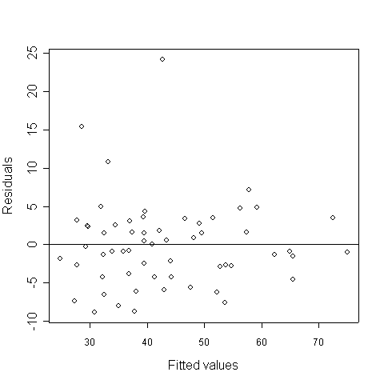
! Plot of residuals versus latitude shows no “pattern”. Check out plot versus longitude:

. plot(resid.full~longi, xlab="longitude", ylab="e(temp|X, longitude)")
. abline(h=0)

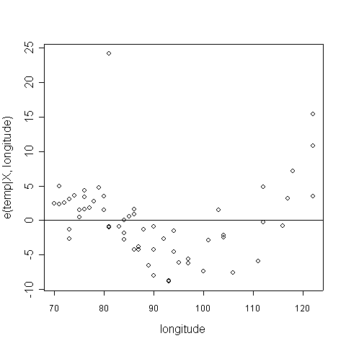

! Based on the clearly nonlinear shape, we will fit curves to the longitude data

# First, center the covariates

. k <- mean(lat)
. l <- mean(longi)
. latc <- lat-k
. longc <- longi-l

# Generate quadratic longitude terms

. lon2 <- longi^2
. lonc2 <- longc^2

# Uncentered model

. summary(lm(fdeg~lat+longi+lon2))

lm(formula = fdeg ~ lat + longi + lon2)

Residuals:
Min 1Q Median 3Q Max
-6.46172 -2.08898 0.01928 0.95892 24.91632

Coefficients:
Estimate Std. Error t value Pr(>|t|)
(Intercept) 278.815077 26.705618 10.440 1.17e-14 ***
lat -2.523056 0.117093 -21.547 < 2e-16 ***
longi -3.153633 0.538635 -5.855 2.76e-07 ***
lon2 0.017465 0.002833 6.166 8.68e-08 ***
---

Signif. codes: 0 `***' 0.001 `**' 0.01 `*' 0.05 `.' 0.1 ` ' 1

Residual standard error: 4.466 on 55 degrees of freedom
Multiple R-Squared: 0.8944, Adjusted R-squared: 0.8886
F-statistic: 155.2 on 3 and 55 DF, p-value: < 2.2e-16

# Centered model: notice the difference re longitude coeff, standard error

. summary(lm(fdeg~latc+longc+lonc2))

lm(formula = fdeg ~ latc + longc + lonc2)

Residuals:
Min 1Q Median 3Q Max
-6.46172 -2.08898 0.01928 0.95892 24.91632

Coefficients:
Estimate Std. Error t value Pr(>|t|)
(Intercept) 39.467207 0.839802 46.996 < 2e-16 ***
latc -2.523056 0.117093 -21.547 < 2e-16 ***
longc -0.006349 0.048213 -0.132 0.896
lonc2 0.017465 0.002833 6.166 8.68e-08 ***
---

Signif. codes: 0 `***' 0.001 `**' 0.01 `*' 0.05 `.' 0.1 ` ' 1

Residual standard error: 4.466 on 55 degrees of freedom
Multiple R-Squared: 0.8944, Adjusted R-squared: 0.8886
F-statistic: 155.2 on 3 and 55 DF, p-value: < 2.2e-16

# A technique to be learned in Class 7: The partial residual plot (good for curve fit check)
# First, generate the partial residuals

. coeff <- lm(fdeg~latc+longc+lonc2)$coeff
. qadjy <- fdeg-(coeff[1]+coeff[2]*latc)

# Now, generate the fit

. qfit <- coeff[3]*longc+coeff[4]*lonc2

# Graph the two versus one another

. plot(qadjy~longc, xlab="longc")
. points(qfit~longc, pch=22)

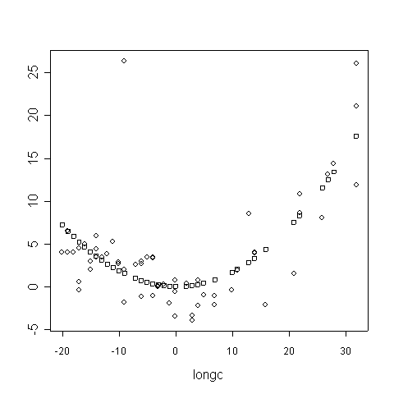

! Now, fit a linear spline model

# First, generate spline terms. We’ll put knots at Louisville, KY and Albuquerque, NM

. lonspl1 <- (longi-85)*(longi>84)
. lonspl2 <- (longi-105)*(longi>104)

# Now, fit the model

. summary(lm(fdeg~latc+longi+lonspl1+lonspl2))

lm(formula = fdeg ~ latc + longi + lonspl1 + lonspl2)

Residuals:
Min 1Q Median 3Q Max
-6.5511 -2.1684 -0.3600 1.0492 24.0080

Coefficients:
Estimate Std. Error t value Pr(>|t|)
(Intercept) 60.0792 12.1702 4.937 8.02e-06 ***
latc -2.4688 0.1165 -21.198 < 2e-16 ***
longi -0.2244 0.1536 -1.461 0.150
lonspl1 0.1383 0.2403 0.575 0.567
lonspl2 1.1868 0.2619 4.532 3.28e-05 ***
---

Signif. codes: 0 `***' 0.001 `**' 0.01 `*' 0.05 `.' 0.1 ` ' 1

Residual standard error: 4.426 on 54 degrees of freedom
Multiple R-Squared: 0.8981, Adjusted R-squared: 0.8906
F-statistic: 119 on 4 and 54 DF, p-value: < 2.2e-16

# Partial residual plot:

. coeff2 <- lm(fdeg~latc+longi+lonspl1+lonspl2)$coeff
. sadjy <- fdeg-(coeff2[1]+coeff2[1]*latc)
. sfit <- coeff2[3]*longi+coeff2[4]*lonspl1+coeff2[5]*lonspl2
. plot(qadjy~longi, xlab="longitude", ylab=””)
. points(sfit~longi, pch=22)

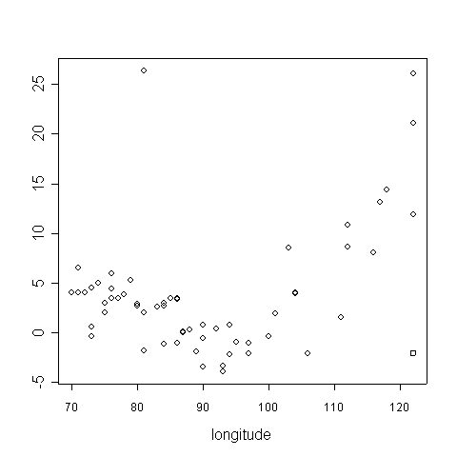

! Finally, let’s initiate an ANOVA model: categorizing latitude and longitude

. west <- longi>105
. east <- longi<85
. south <- lat<39
. longcat <- 2-1*east+1*west

. table(longcat, south)

south
longcat FALSE TRUE
1 16 9
2 12 12
3 6 4

. summary(lm(fdeg~south+east+west))

lm(formula = fdeg ~ south + east + west)

Residuals:
Min 1Q Median 3Q Max
-14.1288 -5.6992 -0.2695 6.4167 17.8712

Coefficients:
Estimate Std. Error t value Pr(>|t|)
(Intercept) 30.545 1.906 16.027 < 2e-16 ***
southTRUE 22.076 2.079 10.616 6.27e-15 ***
eastTRUE 5.507 2.255 2.442 0.0178 *
westTRUE 5.724 2.953 1.939 0.0577 .
---

Signif. codes: 0 `***' 0.001 `**' 0.01 `*' 0.05 `.' 0.1 ` ' 1

Residual standard error: 7.825 on 55 degrees of freedom
Multiple R-Squared: 0.6757, Adjusted R-squared: 0.658
F-statistic: 38.19 on 3 and 55 DF, p-value: 1.772e-13

. summary(lm(fdeg~south+as.factor(longcat)))

lm(formula = fdeg ~ south + as.factor(longcat))

Residuals:
Min 1Q Median 3Q Max
-14.1288 -5.6992 -0.2695 6.4167 17.8712

Coefficients:
Estimate Std. Error t value Pr(>|t|)
(Intercept) 36.0525 1.7348 20.782 < 2e-16 ***
southTRUE 22.0763 2.0795 10.616 6.27e-15 ***
as.factor(longcat)2 -5.5073 2.2551 -2.442 0.0178 *
as.factor(longcat)3 0.2169 2.9290 0.074 0.9412
---

Signif. codes: 0 `***' 0.001 `**' 0.01 `*' 0.05 `.' 0.1 ` ' 1

Residual standard error: 7.825 on 55 degrees of freedom
Multiple R-Squared: 0.6757, Adjusted R-squared: 0.658
F-statistic: 38.19 on 3 and 55 DF, p-value: 1.772e-13

Data listing

Max. Jan. Temp.

Fahrenheit degrees
City 1931-1960 City latitude City Longitude

Mobile, AL 61 30 88
Montgomery, AL 59 32 86
Juneau, AK 30 58 134
Phoenix, AZ 64 33 112
Little Rock, AR 51 34 92
Los Angeles, CA 65 34 118
San Francisco, CA 55 37 122
Denver, CO 42 39 104
New Haven, CT 37 41 72
Wilmington, DE 41 39 75
Washington, DC 44 38 77
Jacksonville, FL 67 38 81
Key West, FL 74 24 81
Miami, FL 76 25 80
Atlanta, GA 52 33 84
Honolulu, HI 79 21 157
Boise, ID 36 43 116
Chicago, IL 33 41 87
Indianapolis, IN 37 39 86
Des Moines, IA 29 41 93
Dubuque, IA 27 42 90
Wichita, KS 42 37 97
Louisville, KY 44 38 85
New Orleans, LA 64 29 90
Portland, ME 32 43 70
Baltimore, MD 44 39 76
Boston, MA 37 42 71
Detroit, MI 33 42 83
Sault Ste. Marie, MI 23 46 84
Minn.-St. Paul, MN 22 44 93
St. Louis, MO 40 38 90
Helena, MT 29 46 112
Omaha, NE 32 41 95
Concord, NH 32 43 71
Atlantic City, NJ 43 39 74
Albuquerque, NM 46 35 106
Albany, NY 31 42 73
New York, NY 40 40 73
Charlotte, NC 51 35 80
Max. Jan. Temp.
Fahrenheit degrees
City 1931-1960 City latitude City Longitude

Raleigh, NC 52 35 78
Bismarck, ND 20 46 100
Cincinnati, OH 41 39 84
Cleveland, OH 35 41 81
Oklahoma City, OK 46 35 97
Portland, OR 44 45 122
Harrisburg, PA 39 40 76
Philadelphia, PA 40 39 75
Charleston, SC 61 32 79
Rapid City, SD 34 44 103
Nashville, TN 49 36 86
Amarillo, TX 50 35 101
Galveston, TX 61 29 94
Houston, TX 64 29 94
Salt Lake City, UT 37 40 111
Burlington, VT 25 44 73
Norfolk, VA 50 36 76
Seattle, WA 44 47 122
Spokane, WA 31 47 117
Madison, WI 26 43 89
Milwaukee, WI 28 43 87
Cheyenne, WY 37 41 104
San Juan, PR 81 18 66

